# Snow Boarder - Group 5

## **1. Overview**

**Snow Boarder** is a 2D survival game where the player controls a character navigating through a snow environment. The player must avoid obstacles, manage limited resources, and collect snowflakes to sustain health. The objective is to survive as long as possible while maintaining a high score.

## **2. Game Mechanics**

### **2.1 Player Controls**

* Rotate to left**: A or Left Arrow**
* Rotate to right: **D or Right Arrow**
* Increase speed**: W or Up Arrow**

### **2.2 Scoring System**

* Players gain **+10 points** for every coin they collect.
* Performing a **360-degree flip** grants **+50 points**.

### **2.3 Health System**

* Players start with 3 health points (3 snowflake icons).
* The game ends when health reaches 0.

## **3. Scene Management**

### **3.1 Load Scene**

* Displays the scene loading to menu



### **3.1 Menu Scene**

* Displays the game title, best score and Start Game button, Instruction button and Quit button .
* Start Game transitions to Level_01.

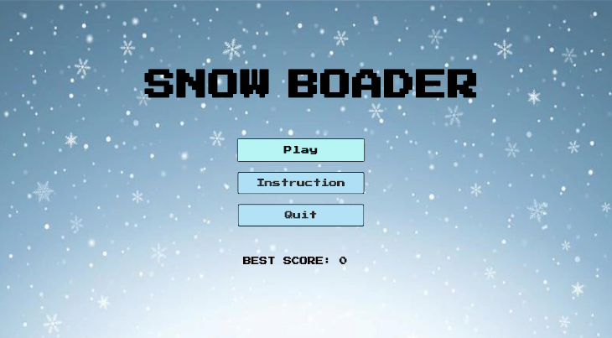

### **3.2 Game Scene (Level_01, Level_02, Level_03)**

* Contains the main gameplay elements.
* Features dynamically changing weather conditions affecting visibility and movement.
* UI Toolkit is used to manage score and health.
* Transitions to the Game Over scene when health reaches 0.
* Level_01: Normal gameplay with snow mountain environment.
* Level_02: Windy weather with falling leaves, extended play path.
* Level_03: Harsh snowstorm, longest play path.

### **3.3 EndGame Scene**

* Displays the final score and best score.
* Offers options to Quit or Return to Menu.

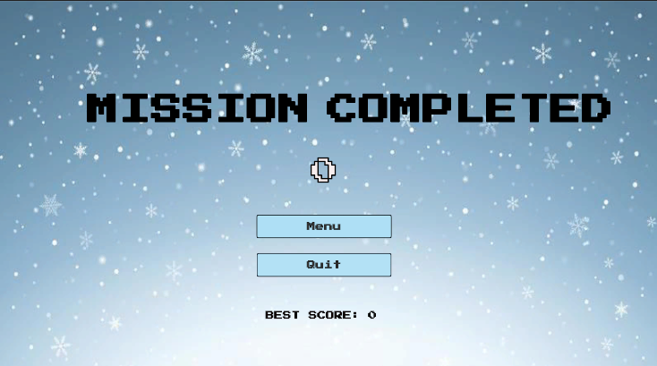

## **4. Game Flow**

1. Player starts in the Menu Scene.
2. Player selects Play, transitioning to Level_01.
3. Player navigates the snowstorm, avoiding obstacles and collecting coins.
4. Health and score update dynamically.
5. When health reaches 0, the game transitions to the End Game Scene.
6. Players can quit or return to the menu.